Functional specifications

Description | Holder keepers module
Author: | H+

Changes of document
Version | Date | Author | Description
1.0 | 27.1.2004 | Matej Štefančič | Initial version

Table of contents
Changes of document 1
Table of contents 2
General description 3
Processes 3
Data validation and business rules 8
User interface 10

General description

HK (holder keeper) module is a part of AIMCS system, where all data regarding addresses, farms and holders are kept. All other parts of AIMCS use this data, which could be seen as the most important code table(s) of AIMCS and therefore only veterinary department can manage data within this module. However it is possible to import data form other (sub) systems like KH data processing software or PDA subsystem, yet this data is at first a suggestion and only when it is reviewed and confirmed, it can be entered into “real” tables.

Processes

Retrieving data from other information systems (IS) – based on questionnaires, data about holder keepers was retrieved from the field. This data was inserted into data processing software where it was double checked and in some cases corrected and filtered. Than it is exported into the following flat (text) files:
- Zip codes file (zip_codes_yyyymmdd_x.txt)
- Cities/settlements file(cities_yyyymmdd_x.txt)
- Veterinary stations file (vet_stations_yyyymmdd_x.txt) and
- Holder keepers file (hk_yyyymmdd_x.txt)
where yyyymmdd is date of export in yyyymmdd format and x is number of export within that day. For example: the first export of holder keepers data on 15.02.2004 would have the following filename: hk_20040215_1.txt

The process of retrieving data from HK data processing software is:
- veterinary department (VD) retrieves flat files
- flat files are uploaded into database (into “temporary” tables) through web interface (see user interface section)
- once data from flat files is stored into database, it can be transferred into “real” tables if “upload from flat file” option is selected on appropriate screen form (see user interface section)
- after retrieval of data, user can decide whether retrieved record is correct or not. If it is, he/she selects checkbox, which confirms that imported record is correct (see user interface section).
  - It is also possible to confirm that all data retrieved from flat file is correct. This can be done if “confirm all imported data is correct” option is selected (see user interface section)
- committing data into database – all data was checked and user wants to commit the correct data into database. During this phase the following sub-tasks occur:
  - when needed, appropriate code is generated for current record (see business rules section for detailed explanation of generating codes)
  - field source in appropriate “real” table is set to “HK_IMP” – signaling that record was retrieved via import from flat file
  - d_update field in appropriate “real” table is set to system date, so that other AIMCS subsystems which retrieve data from HK module are aware of last change of this record occurred (this is especially important to PDA data exchange subsystem)
  - in appropriate “temporary” table field d_transfer, for file which was processed, is set to system date, signaling that this file has been checked and correct data was entered into “real” tables
  - If all conditions for a record were met (see also business rules section), then data is committed into database.

Retrieving data from PDA subsystem – on the field veterinaries will have to check with holder keeper to find out if HK’s data is correct. If data is not correct then veterinary has to enter corrected data into PDA and (when connected to the central I&R system) send this corrected data to the central database. In this case we have the following process:
- HK’s data has to be corrected. Veterinary and holder keeper fill the appropriate form, which has to be signed by holder keeper. Veterinary enters changed data into PDA.
- Veterinary gets to the computer which has access to the central I&R system and with “PDA to central I&R system data exchange” procedure uploads data into appropriate “temporary” tables.
- When VD employee gets signed paper from the field, he/she can add/change data in real tables. There are three possible scenarios:
  - A complete new farm and appropriate related data has to be entered into HK system
  - Existing data has to be changed (due to previous error at inserting or due to change of situation on the field – e.g. street name has changed)
  - Holder keeper for the farm has changed (for example from father to son or due to buying/selling of the farm)
Adding or changing data can be done if “load new/changed PDA data” function is selected on appropriate screen form (see user interface section). User gets a list of all relevant data, with option to select one or more PDA records.
- When PDA data is loaded into screen form, user can decide whether retrieved record is correct or not. If it is, he/she selects (checks) checkbox, which confirms that imported record is correct (see user interface section).
- Committing data into database – all data was checked and user wants to commit the correct data into database. During this phase the following sub-tasks occur:
  - when needed, appropriate code is generated for current record (see business rules section for detailed explanation of generating codes)
  - field source in appropriate “real” table is set to “HK_PDA” – signaling that record was retrieved via data exchange with PDA
  - d_update field in appropriate “real” table is set to system date, so that other AIMCS subsystems which retrieve data from HK module are aware of last change of this record occurred (this is especially important to PDA data exchange subsystem)
  - in appropriate “temporary” table field d_transfer, for record which was processed, is set to system date, signaling that this record has been checked and correct data was entered into “real” tables
  - If all conditions for a record were met (see also business rules section), then data is committed into database.

Manipulating with HK data via screen forms – this is basic way to insert/modify/”delete” data in HK module. When inserting data there is one common rule: to insert data into more complex code table, all underlying data in more basic code tables have to be inserted first. Basic structure (from which sequence of inserting data can be observed) is shown on the following figure:

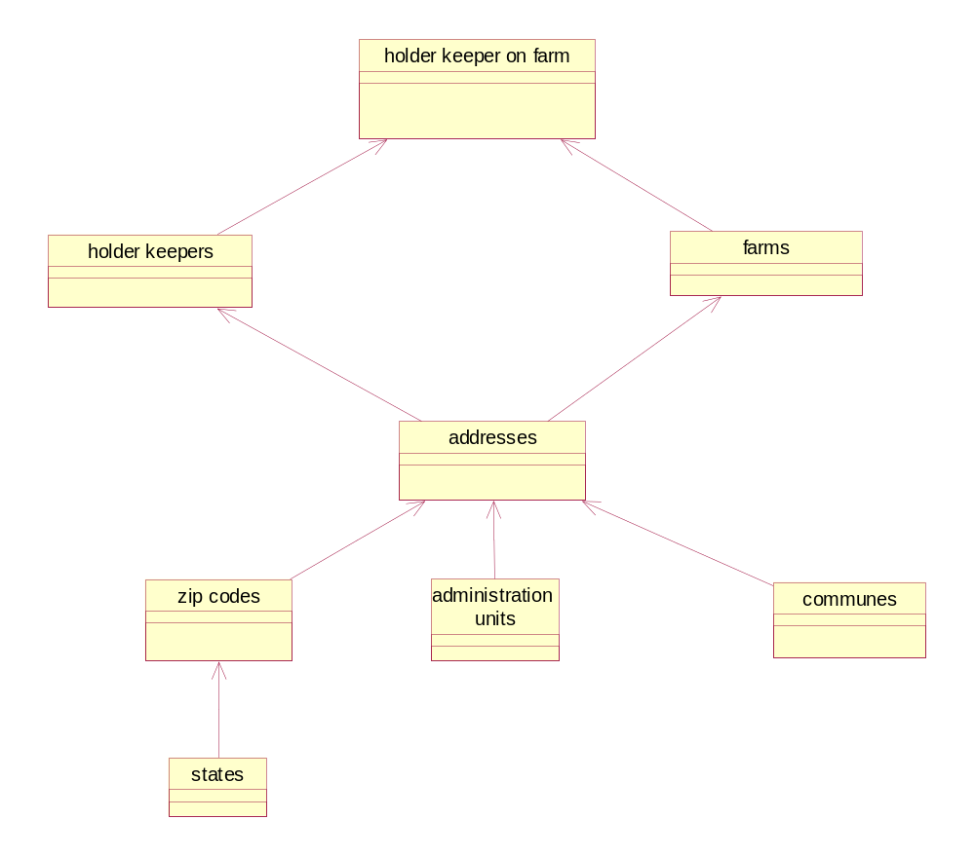
Based on basic data structure as shown above, the process of inserting data into HK module through screen forms is as follows (HK data first):

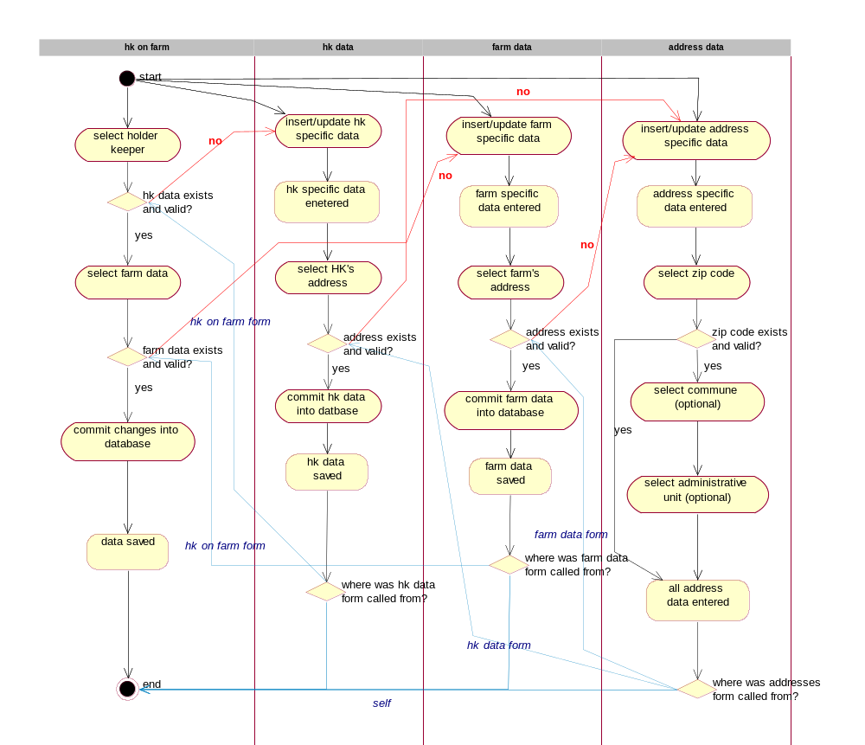

From the diagram above two basic approaches to entering data through screen forms can be observed:
- Drill down approach – user starts entering data “at the end” – holder keepers on the farm. If any of underlying data is missing or is incorrect, then he/she will “drill down” one or more levels, to insert/update underlying data. Then respective codes (for example address code) will be transferred (based on user request) to “higher” levels.
- Simple code tables first approach – user first enters data into basic code tables (zip codes for example). Then more complex code tables are populated (for example addresses).

In some cases it is more convenient to first select/insert farm’s data and then holder keeper’s data. In such cases the following procedure is applied:

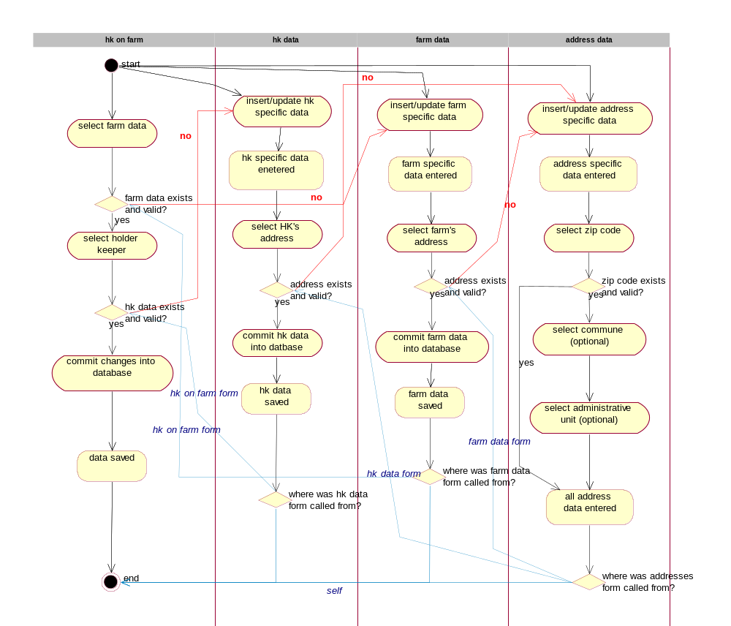

Data validation and business rules

Administrative units:
- Id_admin_unit is number and unique
- Name of admin unit is unique
- Data can not be deleted from admin units code table, however each record can be set to “not valid any more”
- All changes on admin units code table are recorded into respective log table

Communes code table:
- Id_commune is number and unique
- Name of commune is unique
- Data can not be deleted from communes code table, however each record can be set to “not valid any more”
- All changes on communes code table are recorded into respective log table

States code table:
- Id_state is number and unique (number iso code of state – 3 numbers)
- Name of state is unique
- Short name of state has two characters and is also unique (iso short name)
- Data can not be deleted from states code table, however each record can be set to “not valid any more”
- All changes on states code table are recorded into respective log table

Zip codes code table
- Id_zip_code is unique
- Name of zip code is unique
- Each zip code has to have data about corresponding state entered. During insert, user can select only one state from the list of currently valid states
- Data can not be deleted from zip_codes code table, however each record can be set to “not valid any more”
- All changes on zip_codes code table are recorded into respective log table

Addresses code table
- Id_address (hs_mid) is number and unique
- Each address has to have data about corresponding zip code entered. During insert, user can select only one zip code from the list of currently valid zip codes
- X,Y and Z coordinate of address can be entered
- Respective commune and administrative unit of address can be entered
- Value in field owner signals, in what way this record was entered into addresses code table (“direct insert”, PDA, flat file)
- Data can not be deleted from addresses code table, however each record can be set to “not valid any more”
- All changes on addresses code table are recorded into respective log table

Farms code table
- Id_farm (kmg_mid) is number (9 digits) and unique. Structure of this code is as follows:
  - First 4 numbers are number of city/settlement
  - Second 4 numbers are counter within city/settlement
  - Ninth number is a check digit that is automatically generated by this formula:
Check digit = mod 10 of sum of 3*dig1 + 5*dig2 + 7*dig3 + 11*dig4 +13*dig5 + 17*dig6 + 19*dig7 + 23*dig8)
  - The lowest farm number id is 100000014 (in this way fixed length of code is assured)
  - The first 8 digits of the Id_farm can be generated either automatically or entered manually. 9th digit is always computed automatically based on first 8 digits.
- Each farm must have a valid address. During insert, user can select only one address code from the list of currently valid addresses
- Hierarchy of farms can be defined (for each farm superior farm can be defined) – this is very useful when big farms have more “sub farms” or more than one location
- Different type of farm can be set. List of farm types is set in sm_log_codes code table (parameter KMG_TYPE). Possible selections are (it is possible to expand or narrow list according to actual needs):
  - KMG – ordinary farm
  - PAS – pasture
  - VPS – village pasture
  - KLA – slaughter house
  - FAIR – fair
  - VET- veterinary station
  - BRD – border pass
- Value in field source signals, in what way this record was entered into addresses code table (“direct insert”, PDA, flat file)
- Data can not be deleted from farms code table, however each record can be set to “not valid any more”
- All changes on farms code table are recorded into respective log table

Holder keepers code table
- Id_HK (id_ subj) is number and unique.
- Each holder keeper must have a valid address. During insert, user can select only one address code from the list of currently valid addresses
- Value in field source signals, in what way this record was entered into addresses code table (“direct insert”, PDA, flat file)
- Data can not be deleted from HK code table, however each record can be set to “not valid any more”
- All changes on HK code table are recorded into respective log table

Farms for holder keeper code table
- Id HK on farm (id_kmg_subj) is number and unique.
- Each record must have a valid holder keeper. During insert, user can select only one holder keeper’s code from the list of currently valid holder keepers
- Each record must have valid farm. During insert, user can select only one farm’s code from the list of currently valid farms (see user interface section for details).
- Value in field source signals, in what way this record was entered into addresses code table (“direct insert”, PDA, flat file)
- If data on field changed is set, then no document can be produced from the system for current record. This situation usually happens when veterinary on the field found out that data in system does not represent actual situation on field. In this case a proposal for change of data is sent to central I&R system, however those changes are not applied in “real” tables until VD does so.
- Different roles for holder keeper on farm can be set (one per record). This is important if central I&R system is expanded to other species. In this case only new role of holder keeper on farm is inserted.
- Data can not be deleted from HK on farm code table, however each record can be set to “not valid any more”
- All changes on HK on farm code table are recorded into respective log table

Additional rule for transferring data from other (sub) systems:
- Once record was marked for transfer to ”real” tables and “transfer data” button was pressed, it can not be retransferred even if it wasn’t actually written to real tables

User interface

All user interface screen forma are presented in English. In production all screen forms will be in Macedonian language and in Cyrillic code page.

HK-farms screen form (first HK then farm is inserted):

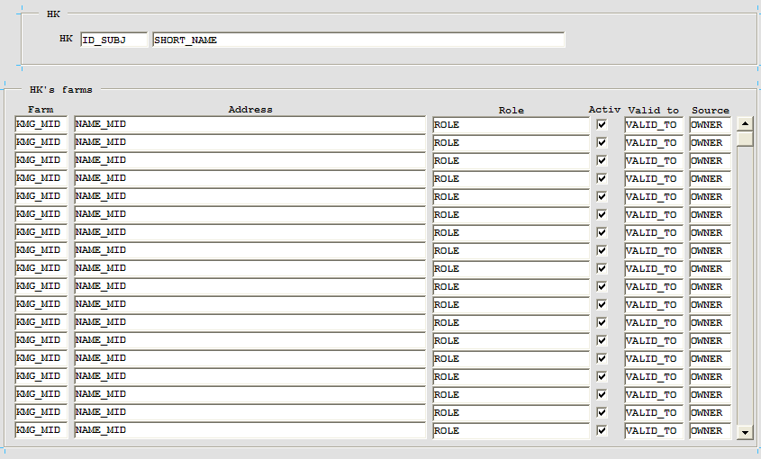

Farm’s HK (first farm, then HK for this farm)

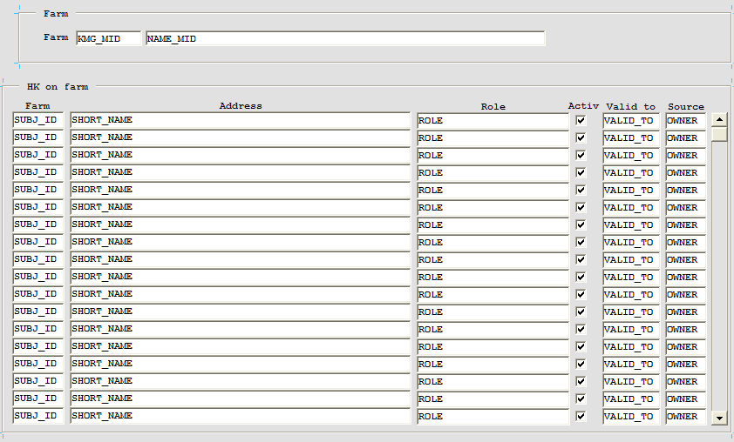

HK screen form:

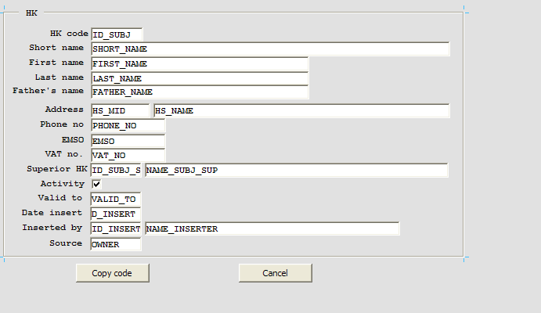

Farms screen form:

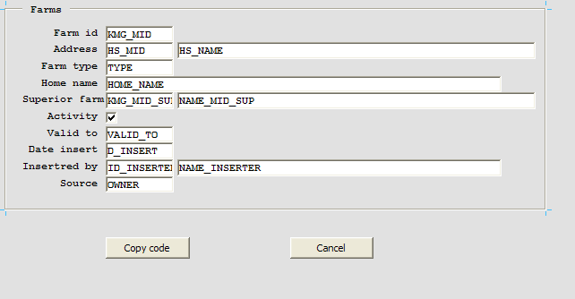

Addresses screen form:

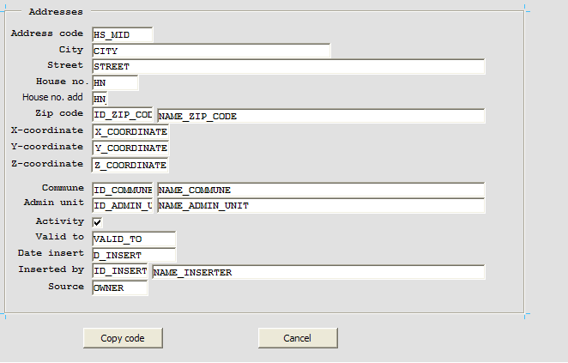

Zip codes screen form:

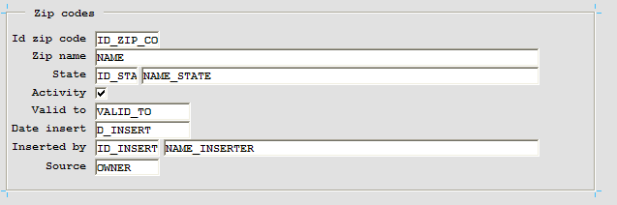

Import of farms data screen form:

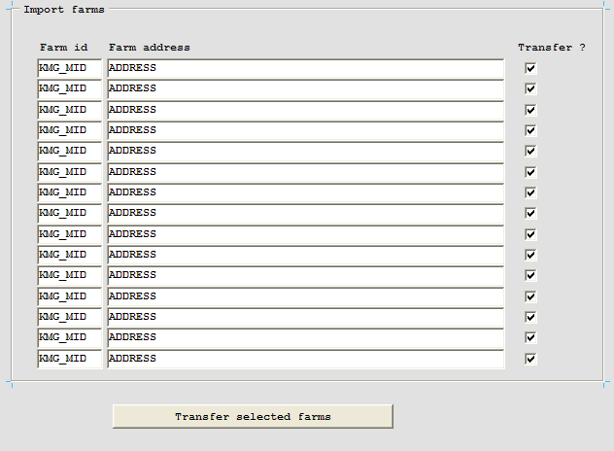

Import of HK data screen form:

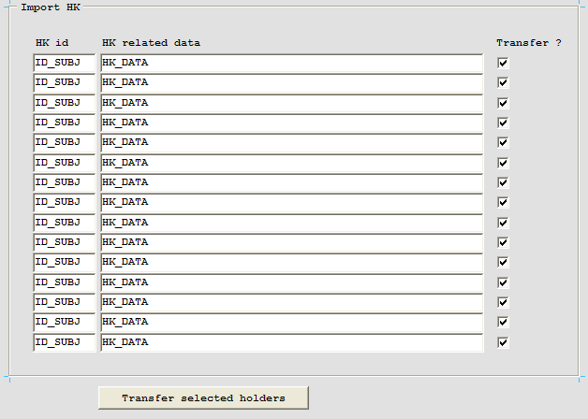

Import of HK on farms screen form:

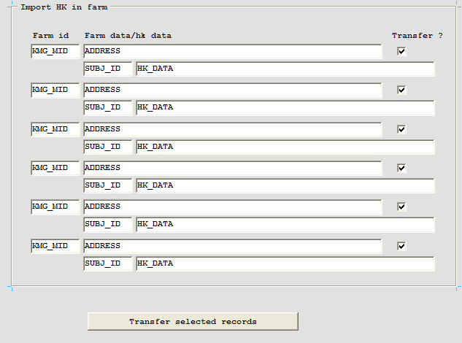

Search parameter form (web)

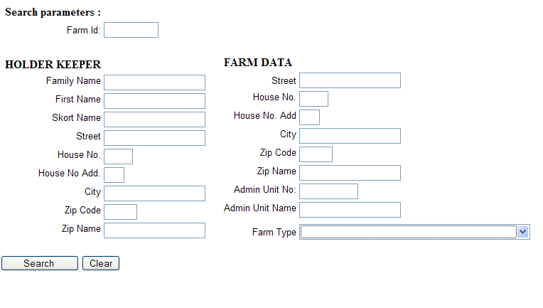

HK module data web preview:

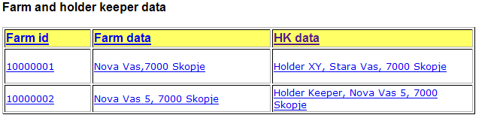

Possible options on the preview shown in figure above:
- Click on any of header link (Farm id, Farm data or HK data) – sort definition: report is reloaded and ordered by column which was selected
- Click on data in first column (except header) – farm id is transferred to appropriate field in other parts of system if right conditions are met (for example if web preview was called from eartags-place an order web form then farm id is transferred into appropriate field on that web form)
- Click on data in second column (except header) – a new web form opens and details about farm are displayed
- Click on data in third column (except header) – a new web form opens and details about holder keeper are displayed

